* 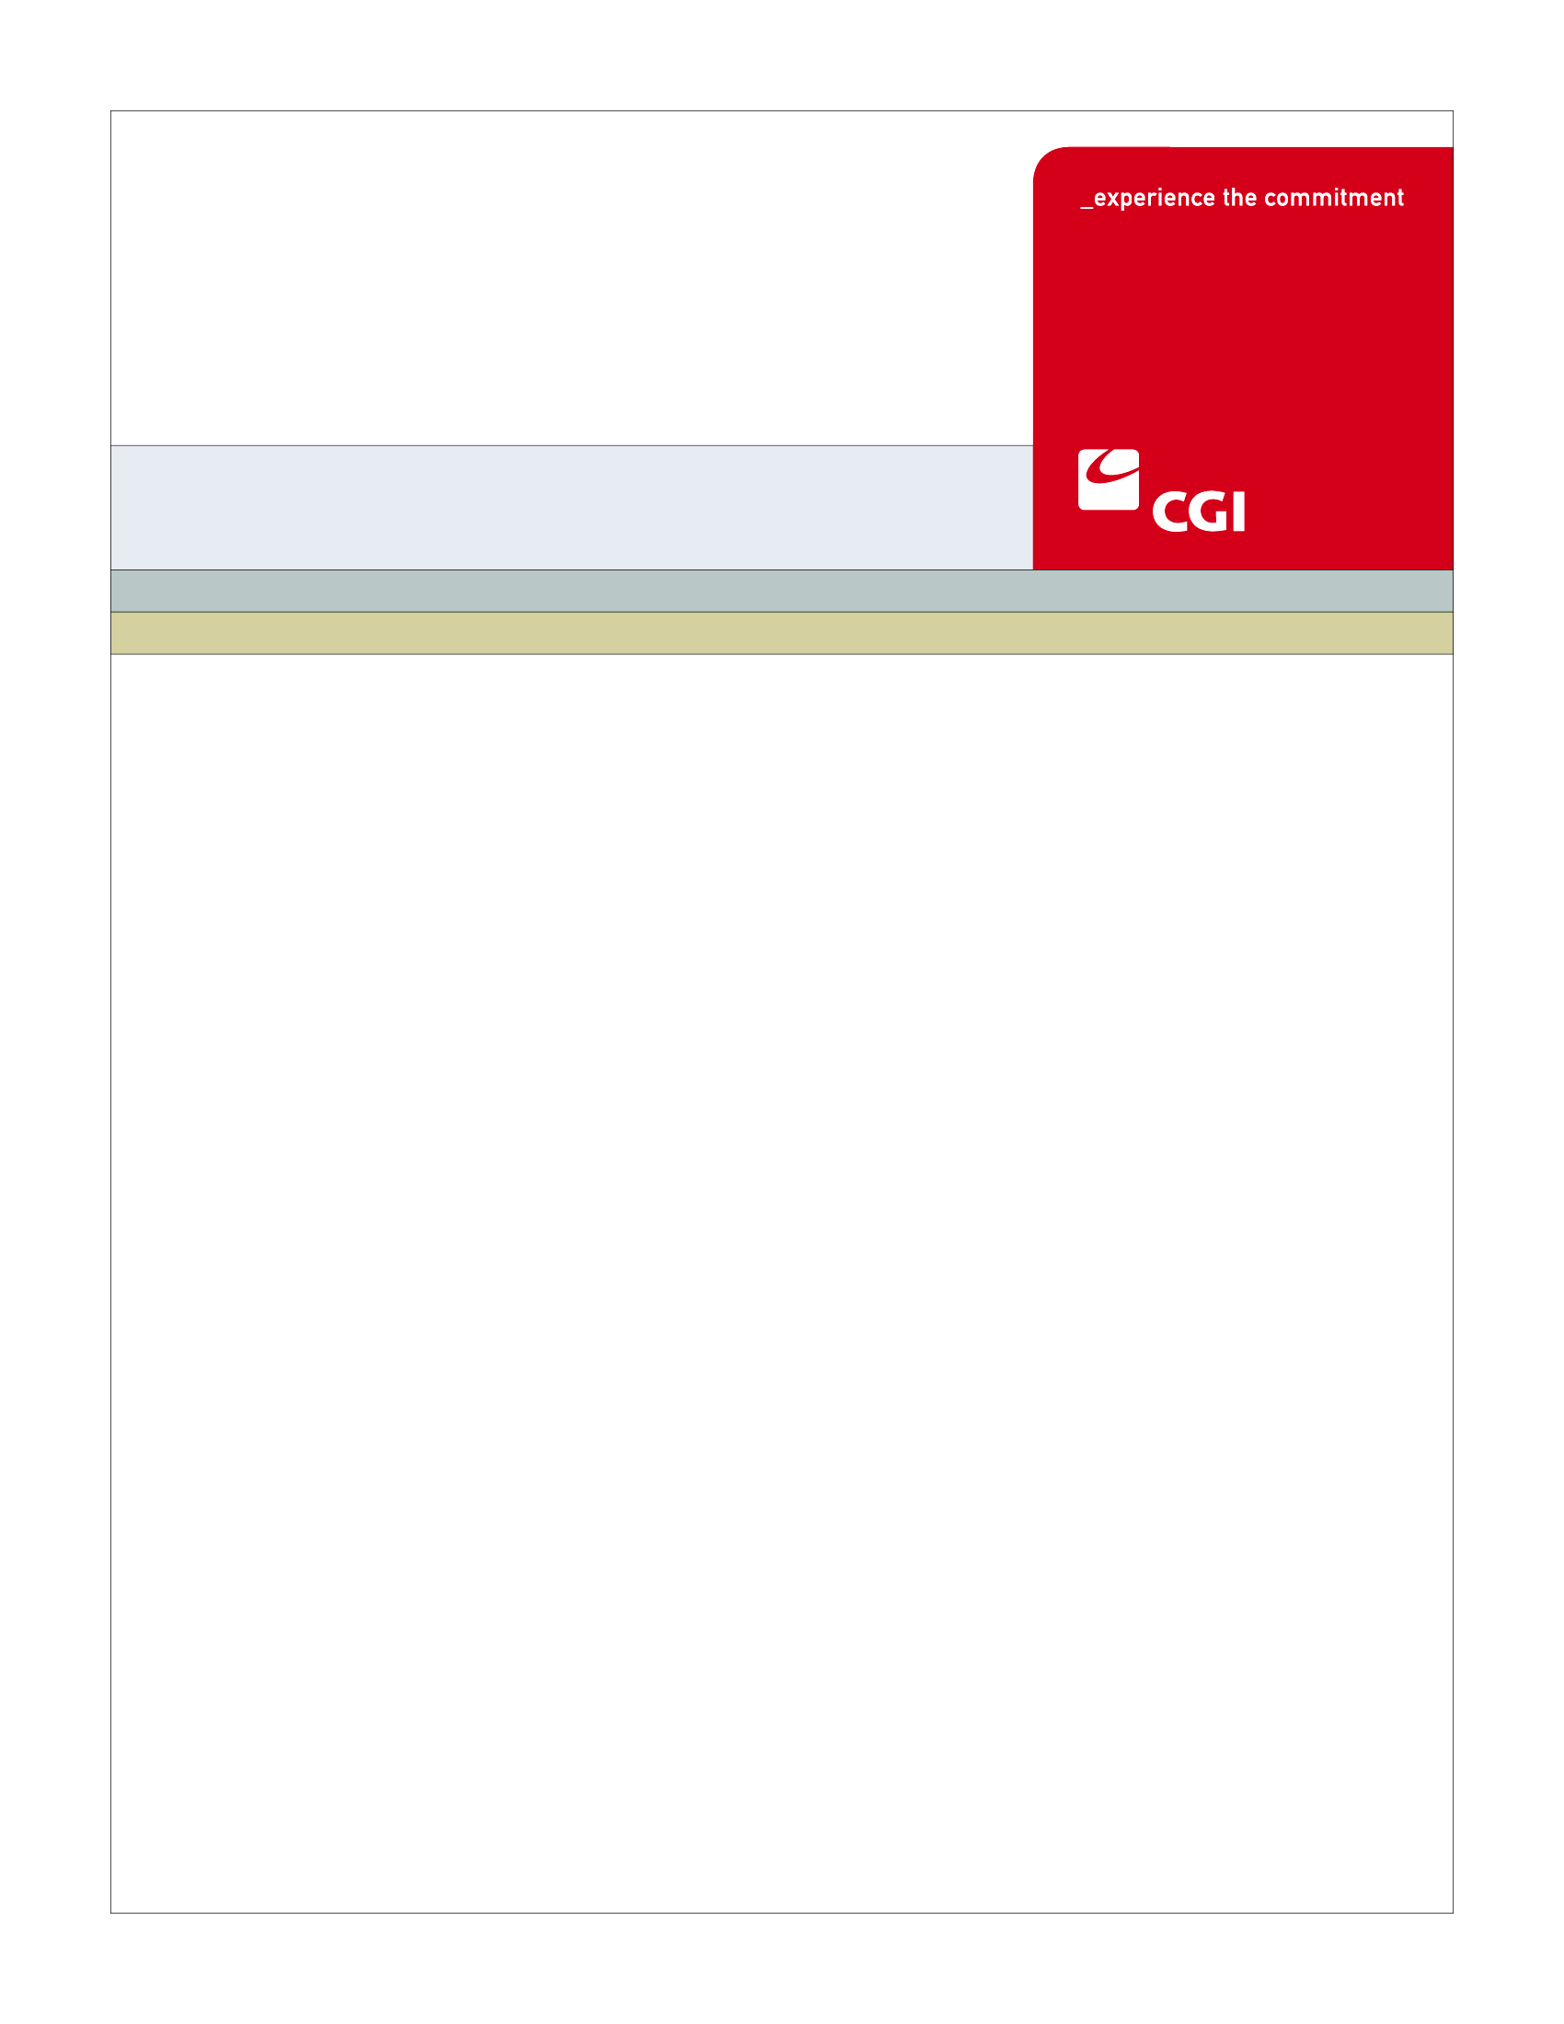USE

**AM012 - Manage Employer Information Use Case**

**Colorado Health Benefit Exchange (COHBE)**

**Version 0.3**

**October 22, 2012**

REVISION HISTORY

|  |  |  |  |
| --- | --- | --- | --- |
| Version | Date | Modified By | Description |
| 0.1 | 09/24/2012 | Diane Dunn, Rob Merry, Kelly Wiley | Initial Draft for Discovery JAD |
| 0.2 | 10/04/2012 | Diane Dunn, Rob Merry | Draft for Elaboration JAD, Incorporating notes from Discovery |
| 0.3 | 10/16/2012 | Diane Dunn | Draft for Verification, incorporating notes from Elaboration |
| 1.0 | 10/22/2012 | Rob Merry | Updated to include Post JAD Verify Comments |

TABLE OF CONTENTS

1 Use Case: Manage Employer Information 5

1.1 Goal 5

1.2 Brief Description 5

1.3 Requirements Traceability 5

1.4 Primary Actor 6

1.4.1 Employer 6

1.4.2 Broker 6

1.4.3 Service Representatives 6

1.4.4 Navigator 6

1.5 Secondary Actor 6

1.5.1 Exchange 6

1.6 Pre-Conditions 6

1.7 Successful Post-Conditions 7

1.8 Triggers 7

1.9 Assumptions 8

2 Flow of Events 8

2.1 Basic (Main) Flow - Manage Employer Information 9

2.1.1 Log into SHOP Portal 9

2.1.2 Retrieves Account Information 9

2.1.3 Review Account Information 9

2.1.4 Update Employer Details? 9

2.1.5 Update Information 9

2.1.6 Update Record 9

2.1.7 Next Steps 9

3 Alternate Flows 10

4 Exception Flows 10

5 Specifications 10

5.1 Business Rules 10

5.1.1 Profile Modifiable Fields 10

5.1.2 Profile Non-Modifiable Fields 10

5.2 Process Rules 10

5.2.1 Update My Account Info 10

5.3 Workflow 11

5.3.1 Worklist Definitions 11

5.4 UI Screen Details 11

5.4.1 UI Flow Considerations 11

5.4.2 My Account/Employer Details 11

5.4.3 My Account/My Profile 11

5.5 Communications 12

5.5.1 Imaging Requirements 12

5.5.2 Form Requirements 12

5.5.3 Notices Requirements 12

5.5.4 Other Communication Requirements 12

5.6 Interfaces 12

5.7 Reporting 12

5.7.1 User Experience 12

5.7.2 Business Activity 12

5.7.3 Workflow 13

5.7.4 Community and Public Health 13

5.8 User Security 13

5.8.1 Actor Status Changes 13

5.8.2 Sensitive Data Used 13

5.9 Activity Log and Audit Trail 13

5.10 Data Elements 14

5.10.1 My Account/Employer Details 14

5.10.2 My Account/My Profile Fields 17

6 Future Release Notes 19

Appendix A – Glossary 19

# Use Case: Manage Employer Information

## Goal

The goal of this Use Case is allow employers to update and manage their account information. An Employer or actor working on his/her behalf, initiates the modification of information associated to his/her account on the SHOP Exchange. Based on the information changed, other processes may occur. For example, the Manage Employee Roster Use Case may be entered if the Employer enters the Manage Employees screen.

This Use Case completes successfully when the Employer has reviewed, added, updated, or deleted information related to their account.

## Brief Description

The Employer will go into the Exchange, click on My Account to review the information stored there. In addition to profile information, the Employer may review account information. Once there, the user can review the information and may choose to change profile information.

Changes in some information will be transmitted to the carrier for any associated employees who are enrolled. A change to the work site address may result in a change in plan availability. If there is no change in plan availability the Use Case will go to Next Steps.

## Requirements Traceability

The following requirements are covered within this Use Case:

* EL015: The Customer, through the Customer’s account profile can view the Customer’s coverage history, notifications, invoices (employers), and enrollment status (employers).
* GF076: Service Representatives will be able to perform all of the activities of the System on behalf of Customers, should Customers need assistance or not have access to the System. Activities of Service Representatives will be limited to the functions required by their roles.
* GF280: The System shall provide the ability to make authorized corrections and modifications after initial entry.
* SH040: The SHOP system will provide employers with an employer homepage to view their current coverage plans, contributions, billing status, etc.
* SH127: Brokers should be allowed to access and perform similar tasks that Employers are allowed to do in the Exchange.

## Primary Actor

### Employer

An Employer who has an account on the system will begin the Manage Employer Information Use Case.

### Broker

Brokers logging in through their Broker account may begin Manage Employer Information Use Case.

### Service Representatives

Removed for separate tracking

### Navigator

Removed for separate tracking

## Secondary Actor

### Exchange

The Exchange validates and stores data. If necessary, the system will send the user to another use case depending on need.

## Pre-Conditions

* User selects Employer Portal.
* Authorized actors will be signed into their own accounts before entering the Employer Portal to manage information for their client.
* Data available to the Manage Employer Information Use Case have been created in the Create Employer Account Use Case and the Determine Employer Eligibility Use Case.

| Data Element |
| --- |
| Primary User Name (First, MI, Last) |
| COHBE Account Number |
| Unique User ID |
| Password |
| Security Questions/Answers 1, 2, and 3 |
| Communication Preference |
| Preferred Language |
| Legal Company Name |
| Name to Display in Exchange |
| Year Established |
| Federal Tax ID /Employer Identification Number |
| Standard Industry Code |
| Previously Self Insured? |
| Employee Count for SHOP Exchange Eligibility |
| Legal Address of Business (no county) |
| Primary Phone, Secondary, Fax Phones for legal address |
| Billing Address of Business (no county) |
| Primary, Secondary, Fax Phone Numbers for billing address |
| Work Site Address of Business (includes county) |
| Primary, Secondary, Fax Phone Numbers for work site address |
| Check box: I am a registered Broker, Navigator, or Service Representative and have the authority to act for this employer |
| Check box: I am the Employer |

## Successful Post-Conditions

* Updates are made to the Employer’s account.
* Data elements listed as required in Section 5.10 are populated.

## Triggers

* User clicks on My Account from any page in the Employer Portal.

## Assumptions

* There is no need to evaluate if changes to My Profile are made during open enrollment since the Employer specifies the open enrollment period for his/her employees.
* Once the Employer has created an account and been approved through the Determine Employer Eligibility Use Case, the employer’s eligibility is not checked again, even if information changes.
* Brokers will have agency agreements in place prior to accessing the client’s Employer Portal account. The agreements will be covered in Broker training.
* Once the Service Representatives and Navigators roles have been defined, the Use Case will need to be updated or new use cases created.
* Text that references caption names may be reworded as part of a future effort to discuss the User Interfaces. Specifically, hCentive uses the term My Eligibility which may need to reworded to better describe the screens.

# Flow of Events

The Business Process Activity diagram below shows the COHBE processes for the Manage Employer Information Use Case. The steps numbered on the diagram below have detailed explanations in the sections that follow.



## Basic (Main) Flow - Manage Employer Information

### Log into SHOP Portal

To access account information, the user logs into the Employer Portal.

### Retrieves Account Information

The system retrieves account information and the data is displayed to the user.

### Review Account Information

The account information is displayed and the Employer may decide to review information specific to the company or update My Account information.

### Update Employer Details?

The My Profile area is where the user’s password and security questions are stored. The My Account is where the company information is stored. In the basic flow, if the user wants to update either the profile information or the company details, proceed to next Step 2.1.5, Update Information. If user is not updating profile or company information, they go to 2.1.7, Next Steps.

### Update Information

The user updates the information in either Employer Details or My Profile (Business Rules, Section 5.1.1 and 5.1.2; Data Elements, Section 5.10).

### Update Record

The system will update the data base record with changes made to the My Account information.

### Next Steps

Based on information that was updated, user can proceed to various next steps, such as:

Manage Employee Roster

Manage Password

Manage Employer Branding

# Alternate Flows

No Alternate flows will be specifically called for the Manage Employers Information Use Case, but next steps could include alternate flows.

# Exception Flows

No Exception flows will be called for the Manage Employer Information Use Case.

# Specifications

## Business Rules

The following business rules will be applied to Step 2.1.4, Update Employer Details.

### Profile Modifiable Fields

* Data Fields on Employer Details is modifiable as defined in Section 5.10.1 and 5.10.2.
* Data includes Security, Employer, Employee Census, Payment Information, Branding, Rating and Contact Information.
* Security Data is not viewable to Broker or Service Representative.

### Profile Non-Modifiable Fields

* Data Fields on Employer Details are not modifiable as defined in Section 5.10.1 and 5.10.2.
* Fields include COHBE Account Number, User ID, Uploaded Documents and Billing Documents.
* Data is viewable to Broker and Service Representatives.

## Process Rules

### Update My Account Info

User will decide if they want to update profile or company information and proceed to update one or more fields on My Account/Employer Details. If they want to update more than just their profile information during open enrollment, they may proceed to Select Plans/Determine Contributions Use Case or Manage Employee Roster Use Case which are part of the Next Steps.

## Workflow

### Worklist Definitions

There are no worklist needed in the Manage Employer Information Use Case. It is assumed all changes will be made online or via phone with the Call Center.

## UI Screen Details

### UI Flow Considerations

The current functionality (September 2012 baseline) of being able to access My Account from any page in the Employer Portal should be maintained.

### My Account/Employer Details

* Employer Details screen needs to be updated to reflect all fields from Create Employer Account for the areas of Company Details, Legal Address, Billing Location, and Primary Colorado Work Site Location. Other fields are in My Profile screen, Section 5.4.3.
* This screen must allow fields to be editable as described in Section 5.10.

### My Account/My Profile

My Profile screen needs to be updated to reflect all fields from the Create Employer Account for the area of Primary User.

Current tabs (along the left side) accessible from My Account are:

* Employer Details (currently labeled My Eligibility in hCentive)
* My Profile
* My Enrollments (Contribution levels are in this tab)
* Enrollment Configurations (this tab includes the Company Logo maintenance and the waiting period for new employees)
* My Documents
* Add to tabs on the left side for viewing by user:
  + My Invoices and Payments

## Communications

### Imaging Requirements

There are no imaging requirements for the Manage Employer Information Use Case as no paper forms are expected to be used.

### Form Requirements

There are no forms requirements for the Manage Employer Information Use Case as no paper forms are expected to be used.

### Notices Requirements

#### Notification of Profile Changes to User

A notification will be sent to users by email for any changes to the profile.

If changes are made to the email or contact preference, a notification will go to the old contact preference or email.

### Other Communication Requirements

There are no other communication requirements for the Manage Employer Information Use Case.

## Interfaces

There are no interfaces for the Manage Employer Information Use Case.

## Reporting

### User Experience

Goal Analysis: What information are employers looking to change most often.

### Business Activity

* Number of accounts changed
* Number of accounts with work site address changes
* Types of changes made – Profile, Non-Profile, Business Identifier Information
* Changes made by Back Office, Service Representatives, Brokers

### Workflow

There are no Workflow Reporting needs for the Manage Employer Information Use Case.

### Community and Public Health

There are no Community and Public Health Reporting needs for the Employer Information Use Case.

## User Security

### Actor Status Changes

No status changes occur in this Use Case. If a data change causes a status change, the triggered Use Case will update the status.

### Sensitive Data Used

No sensitive data will be exposed during this Use Case. Employee data may be exposed as part of triggered Use Case, e.g. Manage Employee Roster.

## Activity Log and Audit Trail

There are no Activity Log and Audit Trail for the Manage Employer Information Use Case.

## Data Elements

Below are the data elements currently captured in the hCentive application.

### My Account/Employer Details

| Process Step Reference | Field Name | Required Field? | Action Taken | Actor Performing Action | Format, if known |
| --- | --- | --- | --- | --- | --- |
| * **For Company Details:** | | | | | |
| 2.1.5 | Legal Company Name | * Required | * May be modified | * User | * at least one character or number, allow for multiple words, embedded spaces |
| 2.1.5 | Name to Display in Exchange | * Required | * May be modified | * User | * defaulted to Legal Name, allow name to be changed manually, at least one character or number, allow for multiple words, embedded spaces |
| 2.1.5 | Year Established | * Optional | * May be modified | * User | * valid year after 1700 through this year |
| 2.1.5 | Was Business Previously Self-Insured? | * Required | * May be modified | * User | * yes or no |
| 2.1.5 | Federal Tax ID | * Required | * Not modifiable | * N/A | * 99-9999999 structure |
| 2.1.5 | Standard Industry Code | * Required | * May be modified | * User | * chosen from look up |
| 2.1.5 | Employee Count for SHOP Exchange Eligibility | * Required | * May be modified | * User | * greater than or equal to 1, less than or equal to 50 until 1/1/16; less than or equal to 100 if 1/1/16 or after |
| 2.1.5 | Employee Count Accurate Attestation | * Required | * May be modified | * User | * If Employee Count for SHOP Exchange Eligibility is updated, this must be checked again |
| * **For Legal Address of Business Location:** | | | | | |
| 2.1.5 | Address Line 1 | * Required | * May be modified | * User | * at least one character or number, allow special characters and embedded spaces |
| 2.1.5 | Address Line 2 | * Optional | * May be modified | * User | * if filled in, at least one character or number, allow special characters and embedded spaces |
| 2.1.5 | City | * Required | * May be modified | * User | * no numbers or special characters |
| 2.1.5 | Postal Code | * Required | * May be modified | * User | * numbers or letters |
| 2.1.5 | State | * Required | * May be modified | * User | * valid state or province |
| 2.1.5 | Primary Phone Number | * Required | * May be modified | * User | * +999-999-9999, default to +1 (USA) |
| 2.1.5 | Secondary Phone Number | * Optional | * May be modified | * User | * +999-999-9999, default to +1 (USA) |
| 2.1.5 | Fax Phone Number | * Optional | * May be modified | * User | * 999-999-9999 |
| * **For Billing Address of Business Location:** | | | | | |
| 2.1.5 | Address Line 1 | * Required | * May be modified | * User | * combination of letters, numbers, and special characters, longer than one in length |
| 2.1.5 | Address Line 2 | * Optional | * May be modified | * User | * if filled in, combination of letters, numbers, and special characters |
| 2.1.5 | City | * Required | * May be modified | * User | * no numbers or special characters |
| 2.1.5 | Postal Code | * Required | * May be modified | * User | * numbers or letters |
| 2.1.5 | State | * Required | * May be modified | * User | * valid state or province |
| 2.1.5 | Primary Phone Number | * Required | * May be modified | * User | * +999-999-9999, default to +1 (USA) |
| 2.1.5 | Secondary Phone Number | * Optional | * May be modified | * User | * +999-999-9999, default to +1 (USA) |
| 2.1.5 | Fax Phone Number | * Optional | * May be modified | * User | * 999-999-9999 |
| * **For Primary Colorado Work Site Address of Eligible Employees:** | | | | | |
| 2.1.5 | Address Line 1 | * Required | * May be modified | * User | * combination of letters, numbers, and special characters, longer than one in length |
| 2.1.5 | Address Line 2 | * Optional | * May be modified | * User | * if filled in, combination of letters, numbers, and special characters |
| 2.1.5 | City | * Required | * May be modified | * User | * no numbers or special characters |
| 2.1.5 | Zip Code | * Required | * May be modified | * User | * numbers |
| 2.1.5 | County | * Required | * May be modified | * User | * from drop down list, must be a valid Colorado county, user may change the county that is auto-populated with zip code; if changed do not revert |
| 2.1.5 | State | * Required | * May be modified | * User | * valid state or province |
| 2.1.5 | Primary Phone Number | * Optional | * May be modified | * User | * +999-999-9999, default to +1 (USA) |
| 2.1.5 | Primary Phone Number | * Optional | * May be modified | * User | * 999-999-9999 |
| 2.1.5 | Secondary Phone Number | * Optional | * May be modified | * User | * 999-999-9999 |
| 2.1.5 | Fax Phone Number | * Optional | * May be modified | * User | * 999-999-9999 |
| * **For Attestations:** | | | | | |
| 2.1.5 | Checkbox: Check box: I am a registered Broker, Navigator, or Service Representative and have the authority to act for this employer | * Conditional – One of the attestation checkboxes must be checked | * May be modified | * User |  |
| 2.1.5 | Check box: I am the Employer | * Conditional – One of the attestation checkboxes must be checked | * May be modified | * User |  |

### My Account/My Profile Fields

| Process Step Reference | Field Name | Required Field? | Action Taken | Actor Performing Action | Format, if known |
| --- | --- | --- | --- | --- | --- |
| * **For the Primary User:** | | | | | |
| 2.1.5 | First Name | * Required | * May be modified | * User | * alpha |
| 2.1.5 | Middle Name | * Optional | * May be modified | * User | * alpha |
| 2.1.5 | Last Name | * Required | * May be modified | * User | * alpha |
| 2.1.5 | Email Address | * Optional | * May be modified | * User | * [name@domain.extension](mailto:name@domain.extension) |
| 2.1.5 | COHBE Account Number | * Required | * Not modifiable | * n/a | * System Generated |
| 2.1.5 | Unique User ID | * Required | * Not modifiable | * n/a | * User Generated |
| 2.1.5 | Password | * Required | * May be modified | * User | * will follow specific password security properties defined in password security properties deliverable |
| 2.1.5 | Communication Preference | * Required | * May be modified | * User | * choice of Email or Mail |
| 2.1.5 | Preferred Language | * Required | * May be modified | * User | * choice of English or Spanish, default to English |
| 2.1.5 | Security Question 1 | * Required | * May be modified | * User | * chosen from a list of several questions |
| 2.1.5 | Security Answer 1 | * Required | * May be modified | * User | * User Entered |
| 2.1.5 | Security Question 2 | * Required | * May be modified | * User | * chosen from a list of several questions and different from Question 1 |
| 2.1.5 | Security Answer 2 | * Required | * May be modified | * User | * User Entered |
| 2.1.5 | Security Question 3 | * Required | * May be modified | * User | * chosen from a list of several questions and different from Questions 1 and 2 |
| 2.1.5 | Security Answer 3 | * Required | * May be modified | * User | * User Entered |
| * **For Attestations:** | | | | | |
| 2.1.5 | Checkbox: Check box: I am a registered Broker, Navigator, or Service Representative and have the authority to act for this employer | * Conditional – One of the attestation checkboxes must be checked | * May be modified | * User |  |
| 2.1.5 | Check box: I am the Employer | * Conditional – One of the attestation checkboxes must be checked | * May be modified | * User |  |

# Future Release Notes

# Appendix A – Glossary

| Term | Definition |
| --- | --- |
| SHOP | Small Employers Health Options Program |